Islands High School Spanish I & II Syllabus

Señora Greenway
Kari.greenway@sccpss.com

Course Description:
In Spanish I & II you’ll learn how to use Spanish to communicate and you’ll learn about Hispanic culture. You will work more on your communication skills in Spanish and make cultural connections through relating, comparing, and contrasting cultural information. By the end of Spanish I, you should be at or above a Novice-High level proficiency & by the end of Spanish II the Intermediate-Low in listening, speaking, reading, and writing, which means…

Objectives:
You will be able to:
- Produce memorized and personalized language
- React appropriately in uncomplicated social situations
- Listen, read, and comprehend novice texts
- List, compare and contrast cultural perspectives, practices and products

Course Requirements/Expectations:
This Spanish class will taught 70-90% in Spanish. You are expected to monitor your conduct and grade. You will need to study daily, turn in assignments on time, and ask me if you need extra help. You are also expected to follow class rules, school rules, and honor the code of conduct.

Materials Needed:
- 3 ring binder, paper, & a writing utensil

Classroom Rules:
- Arrive to class on time with a positive attitude! All I ask is that you try your best!
- Respect the class, including the teacher, other students, and yourself, materials, and the learning environment.
- Eat in the cafeteria, not in class.
ONLY water is allowed in class
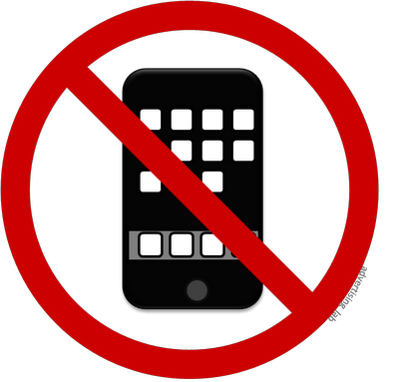
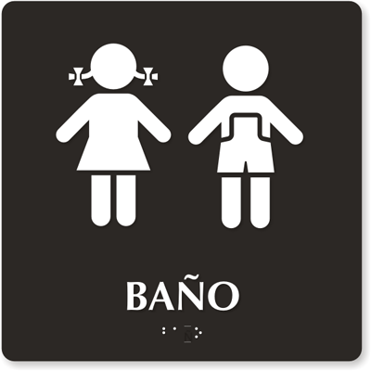
- Electronic devices, including phones & headphones, may be used in class only with the permission of the teacher & only for specified purposes. If you have it out you risk losing your privilege of using it for fun activities.
        - Be academically honest. Don’t use Google Translate or copy off of a friend. Do your own work!

If You Choose to Break a Rule (OTHER THAN PHONES & cheating)
- 1st Offense: Warning
- 2nd Offense: Parent Contact
- 3rd Offense: Parent Contact and Detention
- 4th Offense: Written Notice Requesting Conference will be sent home/ Phone Call Home

**If you are using your phone or headphones without permission, your phone will land in phone jail & you will receive an automatic detention!**

***You will receive an automatic office referral for skipping and/or being defiant.***

Grading:
Assessment: WEEKLY PARTICIPATION, classwork, homework, etc. 40%

Formal Assessments: vocab quizzes, quarterly oral assessments, activities that

serve as assessments, projects, etc. 60%

- Class work:
I will take up some in class activities for grades so that you can receive feedback. I will also walk around and listen in on your conversations and take speaking grades.

- Homework:
Homework mostly consists of studying. Study and practice a little every day! I may occasionally give written homework assignments. They should be turned in at the beginning of class.

- Late work: 10% will be deducted for each day late

DO NOT USE TRANSLATORS! I WILL KNOW WHEN YOU DO!
Any work done with a translator will be given a 0. Spanish-speaking friends may certainly assist and tutor you on an assignment; however, if it is obvious that they did the work for you, rather than assist you, you will receive a 0 for the assignment. Instead of using a translator, use: www.wordreference.com
Tutorials will be held on Monday afternoons 2:30-3:15. Should it change, I will announce it in class.
- Participation:
Each week you will receive a participation grade. Participation is one of the most important components of your grade! To earn points you need to be prepared for class, try your best, try to speak in Spanish, and actively participate in class! If I can see that you are putting forth an effort to learn and practice Spanish then you will get a good grade!

- Quizzes:
Some quizzes will be announced; however we will have unannounced quizzes. So make sure that you are studying vocabulary and reviewing on a daily basis.
- Tests: There will be quarterly speaking tests. Other than those, different activities will serve as tests. There will not be typical formatted tests.
- Projects: I may assign a variety of projects, some as homework and some as in class assignments.
Most grades will be assigned based on the proficiency level you show on the activities:
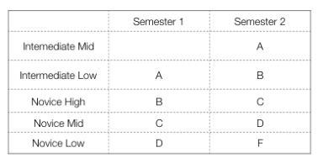
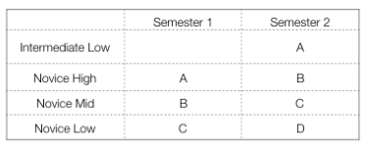
Spanish I Spanish II

Señora Greenway’s Classroom Procedures:
- Entering the classroom:
  - Before entering you should take off your headphones & turn off your phone.
  - Enter after the teacher has opened the door & greet your teacher in Spanish.
  - Place your phone in your assigned pouch.
  - Sit in your assigned seat.
  - If you need to sharpen a pencil, please do so at this time.
  - Turn in any homework/late work to the green bin.
  - Start on the Rompehielos (warm-up activity). You will be given 5-10 minutes to complete it, depending on the assignment. I may take these up, but I may not.
- If you arrive late:
  - You need a pass.
  - Get started on whatever the class is working on.
  - You will receive a detention after 3 unexcused tardies.***
- When you have homework due:
  - Place it in the green bin at the beginning of class, at the end of class counts as late.
- Keeping your desk orderly:
  - Do NOT write/carve on, or put gum on or under the desks or chairs.
- When in class:
  - You are REQUIRED to use as much Spanish as possible! (participation grade)
  - Don’t be lazy! Use what you know! Refer to your Survival Spanish Guide or board.
  - Take your time and just try your best!
  - If all else fails, act it out or ask ¿Cómo se dice? to me or a friend.
- End of Period class dismissal:
  - You may get up when the bell rings. You may NOT line up at the door!
  - Make sure there is not any trash near your desk and that you’re not leaving any personal belongings.
  - Push your chair under.
  - You may retrieve your phone either when I say OR on the way out the door.
- When you are absent:
  - Please see me as soon as possible to get any late work and turn in any homework.
- Going to the restroom during class:
  - If you must use the restroom during class and it is not the first or last 20 minutes of class (10 min on C day) ask your teacher in Spanish (it’s on the wall).
  - Second, fill out your bathroom pass with you name (nombre) & time (hora).
  - I will then sign it & you can go.
  - You will be given 2 passes each marking period. Each pass you do not use may be exchanged for 3 points on a quiz or test grade. Don’t lose them!
  - If I notice that you are leaving my class often then we will have a discussion…
- Going to the media center or another class during class:
  - Take a pass.
  - You’re expected to travel straight to the designated place (NO OTHER).
  - You should not disturb other classes.
  - You are expected to respect everything & everyone wherever you go.
- Fire drill or emergency:
  - If there is an emergency alarm you are to stay seated and SILENT until further instructed by the teacher. DO NOT LEAVE THE ROOM unless told to by the teacher!
  - If we need to leave the room do NOT take any belongs with you.
  - Stay with your class.
  - Listen to the directions of the teacher.

